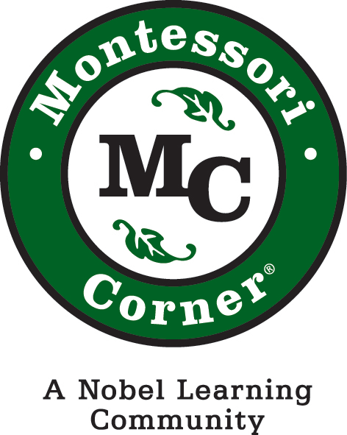

Montessori Country Day School
72 Grovers Mill Road
Plainsboro, NJ 08536

Dear Ivy, Sage and Willow Parents,

We are happy to welcome you to our family! We are looking forward to a successful year with your child here in the Primary program. The Primary program is specifically designed to meet the social, cognitive and physical needs of children ages 3-6. Learning is enhanced through a variety of units of study, hands-on activities and individual lessons based on a Montessori curriculum. Teachers plan individual and whole group experiences that aim to foster the acquisition of new skills and knowledge, the building of learner habits (Habits of Mind) and the cultivation of character through our Character Counts program. Students benefit from an individualized curriculum that focuses on the particular needs of each child. Primary students enjoy enrichment classes that include STEM, art, physical education, music, swim, and Spanish.

We are beginning our plans to welcome you and your family to the new school year and invite you to share your questions and inform us of any important needs your child has as they transition into the start of the 2018-19 school year. The teachers look forward to an amazing school year that includes your family.

Sincerely,
Ivy, Sage and Willow Teachers

Supply List for Primary Ivy, Sage and Willow Students 2018-2019

Quantity | Description
1 | Plastic lunch mat
1 | Friday plastic folder (to take work home)
1 | Plastic drinking cup to keep in the classroom
1 | Shoe-box sized plastic box with lid
1 | Cloth napkin

Please label all of the following items with your child’s name:
- All students need a complete change of uniform clothes appropriate to the season, with underwear and socks, to be left at school.
- All students need sneakers for indoor shoes (Velcro is helpful) No light up shoes.
- Art smock (can be a long t-shirt)
- No violent characters are allowed on any items to be used on school grounds

For Kindergarten students only - In addition to the above items:
- 2 white colored binders (2-3 inches)
- Art: Sketch pad and set of Prismacolor colored pencils

*Please bring only what is specified on this list. Please ensure that your children leave their special belongings and
knick-knacks at home to maintain the integrity of the classroom.

